**Routing Information Protocol (RIP) Configuration**

**Designed Topology:**

**Configuration of Router1:**

Router>enable

Router#config terminal

Router(config)#hostname R1

R1(config)#int Se0/0/1

R1(config-if)#ip address 192.168.20.1 255.255.255.0

R1(config-if)#no shutdown

R1(config-if)#clock rate 64000

R1(config-if)#exit

R1(config)#int Se0/0/0

R1(config-if)#ip address 192.168.10.1 255.255.255.0

R1(config-if)#no shutdown

R1(config-if)#exit

R1(config)#int Gig0/0

R1(config-if)#ip address 192.168.50.254 255.255.255.0

R1(config-if)#no shutdown

R1(config-if)#exit

R1(config)#router rip

R1(config-router)#network 192.168.10.0

R1(config-router)#network 192.168.20.0

R1(config-router)#network 192.168.50.0

R1(config-router)#no auto-summary

R1(config-if)#exit

R1(config)#exit

R1#write

**Configuration of Router2:**

Router>enable

Router#config terminal

Router(config)#hostname R2

R2(config)#int Se0/0/0

R2(config-if)#ip address 192.168.10.2 255.255.255.0

R2(config-if)#no shutdown

R3(config-if)#clock rate 64000

R2(config-if)#exit

R2(config)#int Se0/0/1

R2(config-if)#ip address 192.168.30.1 255.255.255.0

R2(config-if)#no shutdown

R2(config)#router rip

R2(config-router)#network 192.168.10.0

R2(config-router)#network 192.168.30.0

R2(config-router)#no auto-summary

R2(config-if)#exit

R2(config)#exit

R2#write

**Configuration of Router3:**

Router>enable

Router#config terminal

Router(config)#hostname R3

R3(config)#int Se0/0/1

R3(config-if)#ip address 192.168.20.2 255.255.255.0

R3(config-if)#no shutdown

R3(config-if)#exit

R3(config)#int Se0/0/0

R3(config-if)#ip address 192.168.30.2 255.255.255.0

R3(config-if)#no shutdown

R3(config-if)#clock rate 64000

R3(config-if)#exit

R3(config)#int Gig0/0

R3(config-if)#ip address 192.168.40.254 255.255.255.0

R3(config-if)#no shutdown

R3(config-if)#exit

R3(config)#router rip

R3(config-router)#network 192.168.20.0

R3(config-router)#network 192.168.30.0

R3(config-router)#network 192.168.40.0

R3(config-router)#no auto-summary

R3(config-if)#exit

R3(config)#exit

R3#write

**Displaying the RIP routing table:**

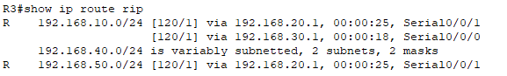

**Displaying the current routing table:**

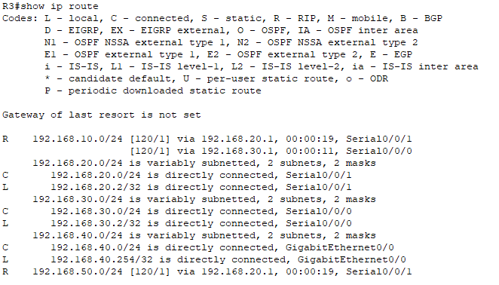

**Displaying detailed information about the RIP Link State Database:**

**Displaying information about the routing protocols:**

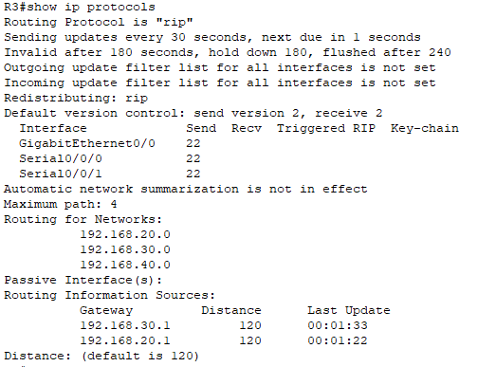

**IP Configuration of Server:**

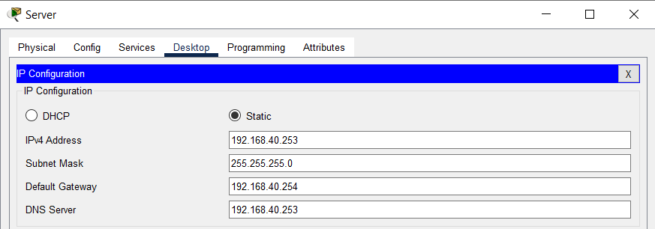

**Creating DHCP Pool:**



**Configuring DNS Service:**

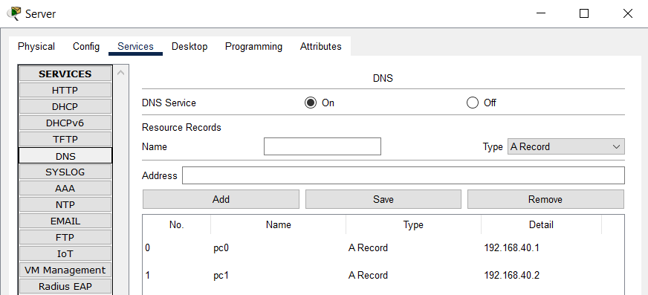

**IP Configuration of PC0:**

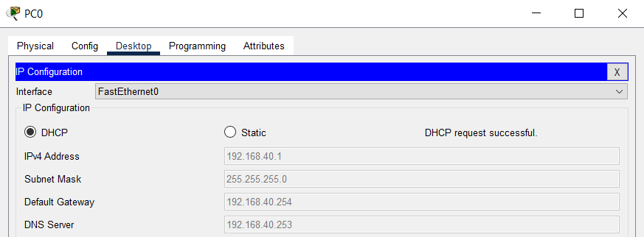

**IP Configuration of PC1:**

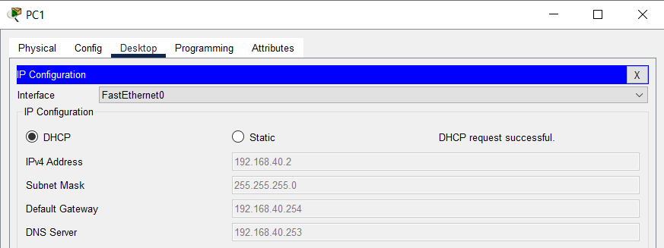

**IP Configuration of Laptop:**

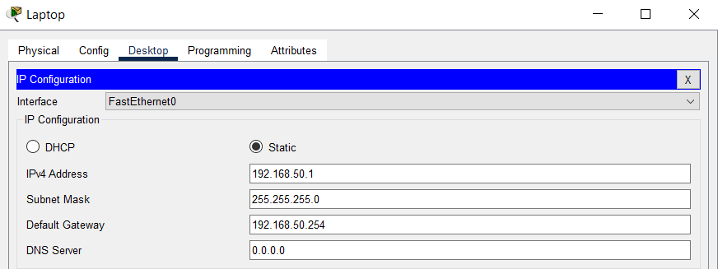

**Checking Connectivity by Pinging From PC0 to PC1:**

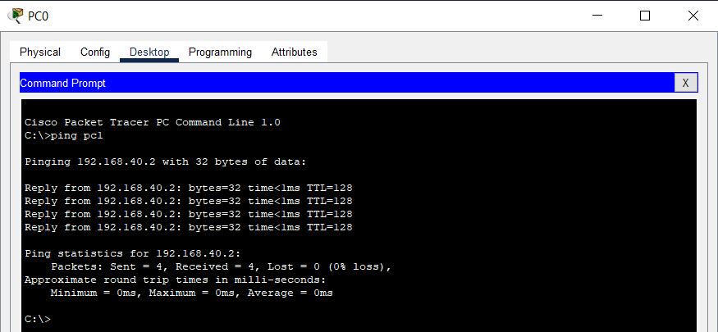

**Checking Connectivity by Pinging From Laptop to PC1:**

